Student Learning Packet
Pre- & Post- Visit Activities
Educators’ version -- with answer keys
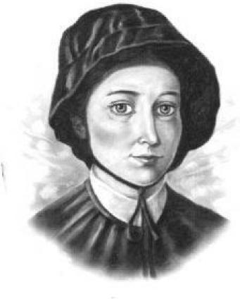
339 S. Seton Avenue
Emmitsburg, MD 21727
301-447-6606 fax 301-447-6061
www.setonheritage.org
1

TABLE OF CONTENTS
Introduction | 3
Curriculum Standards | 4
Pre-Visit Activities | 6
Name Tags | 7
Letter Writing in the 1800’s | 8
Sample of Elizabeth Ann Seton’s Writing | 8
Section 1:Map Skills and Travel | 9
Section 2: Money (Cost of Living) | 10
Section 3: School Days | 11
Section 4: Daily Life | 14
Section 5: Saints and Shrines | 16
Section 6: The American Flag
18
The First American Flag coloring page | 19
Post-Visit Activities | 20
Elizabeth’s Life- Timeline | 21
Elizabeth’s Life- Timeline, answer key | 22
Shrine Quiz | 23
Shrine Quiz, answer key | 26
My Trip to Emmitsburg | 28
Word Find #1 | 29
Word Find #1, answer key | 30
Word Find #2 | 31
Word Find #2, answer key | 32
Basilica Photo Hunt sample............................................................33
Basilica Photo Hunt, answer key | 34
Seton Search example | 37
Vocabulary | 38
Teacher Evaluation | 40

Contents may be copied for classroom use. Not for Resale or Publication.
Cover picture of St. Elizabeth Ann: Iandry Randriamandroso, Vincentian Center,
St. John’s University, Jamaica, NY
In grateful appreciation to Sister Margaret Ann Wooden, D.C.;
Mrs. Barbara McCleary, Shrine docent; and Ms. Jenna Ott, Shrine docent.
With a combined total of sixty years’ teaching experience, their contributions were invaluable!
Many thanks also to Bonnie Weatherly of Archives, St. Joseph’s Provincial House, for providing source
documents and pictures and help in reproducing them.

2

Introduction
The National Shrine of St. Elizabeth Ann Seton is pleased to provide educators with digital copy of the student learning packet of pre-visit and post-visit activities for classroom use to aid in a stimulating and enjoyable tour of the Seton Shrine.
These activities may fulfill the Maryland and West Virginia curriculum standards listed on the next page. Please choose the activities that are appropriate for your age group and grade.
A trip to the Seton Shrine provides a perfect opportunity for students to learn about an outstanding American woman and the impact that she had on education and service to the sick and the poor. They will be able to compare and contrast their own modern conveniences with life in the early 19th century by viewing artifacts from the time, and by reading excerpts from her writings.
The museum is in a beautiful building surrounded by park-like grounds. Friendly docents will answer questions and show a 15 minute video on the life of Mother Seton. On display are pictures, a desk used by Mother Seton, and interesting displays of the history of the birth of the first American community for religious women in the U.S.
Mother Seton was the foundress of the Sisters of Charity of St. Joseph’s. In 1809 Mother Seton and nine candidates moved into the Stone House where they endured many hardships. Sixteen people occupied four rooms and there were few conveniences. It is remarkable to note that in 1979 the house, which weighs 328 tons, was moved to its present site.
In 1810, the community moved into what is now known as the White House, where they were able to accommodate boarding students. It too was moved in 1848 so other buildings could be constructed. During Mother Seton’s lifetime they cared for orphans, the sick, taught catechism at the Mount, as well as teaching day students and boarders.
Modern-day students will be able to see a room set up as a classroom, complete with tiny chairs, slates, and other classroom supplies of 1810. They can learn about the religious composition of early settlers in Maryland and why they came here, how they lived, and how they endured. They can see the impact made by one tiny woman and her group of sisters in a time when women had very few opportunities to make an impact on the world.
Visitors may see the magnificent basilica that was built in 1962, and currently holds the remains of the first, native-born American saint, Elizabeth Ann Seton.
WHAT YOU CAN DO WHEN YOU VISIT THE SHRINE
Common Visit Itinerary for School Groups:
Watch the Seton Film in museum’s theater (running time of 16 minutes)
Take the Seton Way Tour; guided tour to historic homes of Mother Seton, Stone House and White
House, the Legacy Garden, and the Original Cemetery
Work on the Seton Search while on tour
Visit the Basilica and listen to the docent’s historical presentation
Do the Basilica Photo Hunt (extra 15-30minutes may be needed to complete)
Tour the Museum, Charity Afire Exhibit
Shop in the Gift Shop for one of a kind items on St. Elizabeth Ann Seton

3

Curriculum Standards
The following curriculum standards may be satisfied on a field trip to the National Shrine of St. Elizabeth Ann Seton: MARYLAND SOCIAL STUDIES STANDARDS:
SS. 100.10 – Students will demonstrate an understanding of historical and current events using chronological and spatial thinking, develop historical interpretations, and frame questions that include collecting and evaluating information from primary and secondary sources.
SS.100.30.06 – Describe how transportation and communication networks link communities.
SS.100.30.07 – Portray different methods of transportation, past, present and future on land, water and air. SS.100.60.07 – Identify how individuals and careers have contributed to the development of community
SS.200.10.01 – Distinguish among past, present and future time
01.a – Compare community life now to community life in the past.
SS.200.10.02 - Describe people, places and events in the past
02.a - Interpret a variety of print and non-print sources of information about the past
SS.300.10 – History: Students will examine significant ideas, beliefs, and themes; organize patterns and events; and analyze how individuals and societies have changed over time in Maryland and the United States. Students will use historical thinking skills to understand how individuals and events have changed society over time.
SS.300.10.02 – Identify people who contributed to the history of Frederick County
SS.300.20.03 – Explain how transportation and communication networks link places by the movement of goods, people and ideas.
SS.400.10 – Students will demonstrate an understanding of historical and current events using chronological and spatial thinking, develop historical interpretations, and frame questions that include collecting and evaluating information from primary and secondary sources.
SS.500.10 – Same as SS.400.10
SS.500.10.03 – Find, interpret and organize primary and secondary sources of information including pictures, graphics, maps, atlases, artifacts, timelines, political cartoons, videotapes, journals, and government documents.
WEST VIRGINIA SOCIAL STUDIES STANDARDS:
Standard 1: Citizenship (SS.S.1) Students will
- describe, demonstrate and employ the civic dispositions of good citizenship (Civic Dispositions);
- develop a respect for symbols, ideas and concepts of the United States and describe the roles of significant individuals (Respect For People, Events, and Symbols);
- develop and employ the civic skills necessary for effective citizenship by using criteria to make judgments, arrive at and defend positions and evaluate the validity of the positions or data (Evaluation Skills);
- demonstrate and employ the participatory skills of interacting, monitoring and influencing that are essential for informed, effective and responsible citizenship, including participation in civic life to shape public policy (Participatory Skills); and
- explain and practice the responsibilities, privileges and rights of United States citizens (Civic Life).
4

Standard 4: Geography (SS.S.4) Students will:
- interpret, use and construct maps, globes and other geographic tools to locate and derive information about personal directions, people, places and environments (The World in Spatial Terms);
- describe the physical and human characteristics of place and explain how the lives of people are rooted in places and regions (Places and Regions);
- describe and explain the physical processes that shape the earth’s surface and create, sustain and modify the cultural and natural environment (Physical Systems);
- identify, explain and analyze how the earth is shaped by the movement of people and their activities (Human Systems);
- analyze the interaction of society with the environment (Environment and Society); and
- explain geographic perspective and the tools and techniques available for geographic study (Uses of Geography).
Standard 5: History (SS.S.5) Students will:
examine, analyze and explain historical relationships using chronology to sequence and organize events and
people in history (Chronology);
use the processes and resources of historical inquiry to gather, examine, compare, analyze and interpret
historical data (Skills and Application);
examine, analyze and synthesize historical knowledge of major events, individuals, cultures and the
humanities in West Virginia, the United States and the world (Culture and Humanities);
examine political institutions and theories that have developed and changed over time (Political Institutions).
WEST VIRGINIA READING CONTENT STANDARDS K-12:
Standard 1: Reading (RLA.S.1)
Students will use skills to read for literacy experiences, read to inform and read to perform a task by identifying and using the dimensions of reading (phonemic awareness, phonics, background knowledge/vocabulary, high frequency words/fluency, comprehension, writing and motivation to read); and employing a wide variety of literature in developing independent readers.
Standard 2: Writing (RLA.S.2) Students will employ a wide range of writing strategies to communicate effectively for different purposes by: developing the writing process; applying grammatical and mechanical properties in writing; and gathering and using information for research purposes.
Standard 3: Listening, Speaking and Viewing (RLA.S.3)
Students will apply their use of spoken, written and/or visual language to communicate with a variety of audiences
and for different purposes.

5

Pre-Visit Activities
WHAT YOU CAN DO TO PREPARE FOR A VISIT:
- Color and fill out your name tag to wear when you come here.
- Print out the Seton Search, Shrine Quiz, or My Trip to Emmitsburg for students to work on when they are here.
- Visit our web site www.setonshrine.org to learn more about St. Elizabeth Ann Seton.
- Read stories about colonial life in America to learn about her childhood.
- Discuss what school was like for the children in the Early American Republic.
- Read about how a person becomes a saint.
- Learn about St. Elizabeth Ann Seton’s children.
- Put on a play about Mother Seton starting a girl’s school.
- Think of questions you would like to ask the staff person at the Shrine.

6

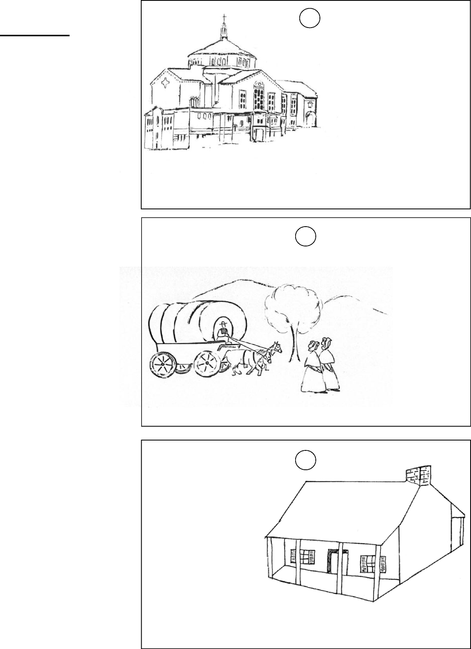
Pope John XXIII March 17, 1963
DIRECTIONS
In a house that was very small but with ample space for charity, she sowed a seed in America by which Divine Grace grew into a large tree.”
The Basilica of the National Shrine of Saint Elizabeth Ann Seton
- Determine how many copies you will need, and print and cut out each.
- Choose one of three tags, print your name and color
the picture
- Hole punch and loop yarn through to make a lanyard
- Wear the name tag around your neck for your visit
* for durability, laminate the name tags or insert into name tag plastic sleeves.
“...all the natives [were] astonished...the dogs and pigs came out to meet us and the geese stretched their necks in mute demand to know if we were any of their sort...”
The journey from Baltimore to Emmitsburg, 1809
NAME TAG
Have each of your students make a name tag before visiting the National Shrine of Saint Elizabeth Ann Seton
7
“While sleeping at the stone house, the snow would drift in...did not discover that [our] beds were partly covered with snow... until day began to dawn through the cracks of the boards.”
The Stone House, 1809

LETTER WRITING IN THE 1800’s
Elizabeth Ann Seton was a very prolific writer. She kept a journal, and frequently wrote letters to her family and friends. It is good that we have copies of many of these letters because they tell us about her life and the times in which she lived. Look for the copies of her letters in this packet. It may be a challenge to read them because some of the words may appear to be misspelled. Look for differences in how we write today.
Why did people write so much and so often? Think about it: with no computers, no instant messaging, no email, no television or even telephones, writing was the only way to keep in touch and communicate with others, especially when people were separated by distance. With no radio or television to occupy them in the evenings, keeping a journal was also a way to pass the time.
When you visit the shrine, look for the copy of Mother Seton’s Last Will and Testament, which is in the White House. You will see it in her own handwriting with an easier-to-read translation beside it. Some of the following activities are based upon Elizabeth Ann Seton’s letters, which are carefully preserved and used here courtesy of the Archives Daughters of Charity, Emmitsburg Province.

“Friday - Saturday- and Sunday are past my dear one with many a prayer - many a sigh - rocking and rolling without getting on - Ann is suffering every way very low spirited - refusing to go on deck - the ladies on board, Mrs. Smith and her daughter, so good to us - coaxing us with almonds and raisins (You remember poor Sister's human Affections) --Kissior and Rebecca are not half so sick as Ann - said our Vespers during a squal - very fervently you may be sure

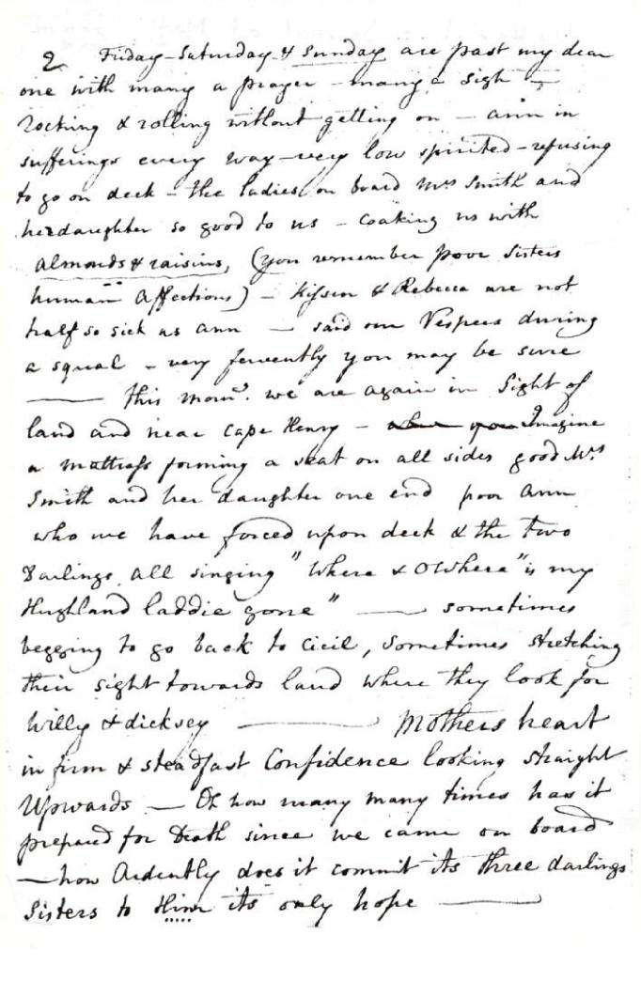
8
-- This morning we are again in sight of
land and near Cape Henry- Imagine a mattress forming a seat on all sides, good Mrs. Smith and her daughter one end, poor Ann who we have forced upon deck and the two Darlings all singing "Where and O Where is my Highland laddie gone" -- sometimes begging to go back to Cicil, sometimes stretching their sight towards land where they look for Willy and Dicksey -- Mothers heart in firm and steadfast Confidence looking straight Upwards -- Oh how many many times has it prepared for Death since we came on board -- how Ardently does it commit its three darlings Sisters to Him its only hope--”

Section 1: Map Skills And Travel
In 1808, Mother Seton and her three young daughters left their home in New York City to open a school for girls on Paca Street in Baltimore, Maryland. Elizabeth considered going by land, but a journey that way would have taken two or three weeks, and at greater expense. Read Letter 1, which describes their journey aboard the Grand Sachem. When you visit the museum, look for the picture of the boat.
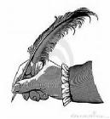 | LETTER 1 Journal of Mother Seton 1808  June 13- “Friday, Saturday and Sunday are past, my dear one, with many a prayer, many a sigh; we are rocking and rolling without getting on. Ann is suffering every way...This morning we are again in sight of land and near Cape Henry.”  June 14- “After rolling and dashing all night... with both little dear ones in my narrow berth, the hand held over to Ann, praying every ten minutes and offering the life so justly forfeited, here we are flying up the Chesapeake. A fairer wind and lighter hearts never went through it, I believe. The sun is setting gloriously...Are you looking at it?”

June 15- “ Evening once more...aboard the Grand Sachem. Not yet in Baltimore Bay. Hope is on the wing, expecting tomorrow morning.”
June 16, morning- “ Since eleven last night we are at the wharf but cannot quit the
vessel until our things are entered at the custom house. It rains very hard.”
Evening- “...all I can tell you is [that] a carriage conveyed us to the seminary.”
In 1809, Mother Seton and her companions left Baltimore to go to their new home in Emmitsburg, Maryland. She and four others walked the entire distance. Read Letter 2, which tells some of the sights they saw on the way.
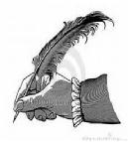 | LETTER 2 Elizabeth Ann Seton to W. Dubourg, SS 1809  June 21- “We are so far safe though our progress is so much slower than you expected. Your turnpike road is...a very rough one, and we were obliged to walk the horses all the way and have walked ourselves...except Cecelia [Cecelia Seton, Elizabeth’s sister-in-law, was suffering from a prolonged illness] nearly half the time, this morning four miles and a half before breakfast. The dear patient was greatly amused, and all the natives astonished as we went before the carriage. The dogs and pigs came out to meet us, and the geese stretched their necks in mute demand to know if we were any of their sort, to which we gave assent.”

ACTIVITIES
- Compare and contrast the different ways to travel in 1800 and now.
- Find New York City, NY; Baltimore, MD; and Emmitsburg, MD on today’s map. How far did they have to travel on each journey? How long would it take someone to drive from New York to Baltimore today?
- What things would be necessary for journeys of this sort then and now?
- What advantages, if any, did a sea voyage have over a stage coach journey?
- From reading the letters, how would you describe the conditions of travel at this time?
- Mother Seton talks of a turnpike. What is a turnpike?
9

Section 2: Money (Cost of Living)
Read Letters 3 and 4 from Mother Seton to her dear friend Julia Scott, which describes her life at the boarding school on Paca St. in Baltimore, MD, and what things cost.
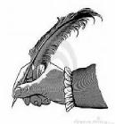 | LETTER 3 to Julia Scott 1808  July 4- “I have the advantage of procuring everything I use from the seminary [St. Mary’s College and Seminary in Baltimore] which, as they engage by the gross, makes a difference of at least a third less expense in every article. The difference of wood at $5.50 a cord without cartage or $3 a load is very great. A neat delightful mansion at $250 instead of $350, entirely new in the French style of folding windows and recesses, is also very great. My boys are finally received in the college by the voluntary offering of these kind beings, who are the professors, without the least expense, which saves me... $400... A very good servant at $4.50 per month does my washing, cleaning and cooking.”  LETTER 4 to Julia Scott 1808  October 10- “You ask my terms. They are $200 per year; extra accomplishments which require the assistance of masters, as music, drawing, are paid separately. The masters engaged... [by] the college attend at my house on the most moderate terms though they are the best that can be procured. Everybody here seems to pity the poor little widow. You would hardly believe my baker’s bill from the college for three full months is $8.88, the butchers $18.50, and the best wood, including carting, $4.25 a cord. Very different from New York where I often paid $3.25 per load in winter...”

ACTIVITIES
- A servant is paid $4.50 per month. What is your allowance? Do you receive more or less than the servant? What activities or items can you buy for $4.50 a month?
- Keep a financial record of what you spend for a week. How does this compare with what Mother Seton paid for items in her day?
- A load of firewood cost $3.00. What can you buy for $3.00 today? What is the amount of money Mother Seton would have paid in today’s dollars?
- From store ads, make a list of what you would need for a week of groceries. How much would it cost?
10

Section 3: School Days

In the late 18th and early 19th centuries in America, education was considered mainly a family or local responsibility, not a responsibility of the state. Some regions had widespread availability of local schools, while other regions offered few formal schools for their residents. Schooling was conducted in the home, in small, one-room schoolhouses or the home of a local teacher. The general curriculum centered on reading, writing, and arithmetic along with moral and religious training. Education for girls and boys differed in many places. Girls were often expected to learn subjects such as needlework and French. Boys would often learn Latin, and more advanced math and science. Boys and girls were taught the skills of farming or apprenticed to learn a trade. Girls also were taught homemaking skills such as knitting and bookkeeping. However, children of professionals received a wider education. Elizabeth Ann was taught French, music, and painting.
In 1805, a widowed Elizabeth Ann Seton oversaw a school in New York City because of the need to support herself and her children. Sadly, during the most vulnerable time in her life, many of her friends did not agree with her decision to become a Catholic and would not send their children to the school. This was a difficult time for her. It must have been reassuring to her then when Father Dubourg offered an opportunity to move to Baltimore, Maryland and begin a school in that state where a population of Catholics had already settled. She did just that; and later, in 1809, she traveled to Emmitsburg, MD, where she would establish the first free school for girls staffed by religious sisters. This was significant in several ways: it was a free school; and because “as late as 1815...not a single state had a comprehensive public school system. Instead, schooling became primarily the responsibility of private institutions, most of which were open only to those who could afford to pay for them.”¹ Her school educated girls, from diverse social, economic, and religious backgrounds, and it was the first of its kind in the United States.
Mother Seton has been called a pioneer in Catholic education. This “free school” in Emmitsburg, which began on February 22, 1810, was a prototype for the Catholic parochial school system. Before her death in 1821, her Sisters had gone out from the Emmitsburg valley to staff five schools in Philadelphia and New York.
Carefully read the following accounts, in which Mother Seton talks about different aspects of school life in her time. Then try the activities listed there.

¹ Quote from American History 7th edition, vol. 1: to 1877. Copyright 1987, Knopf, New York.
11

LETTER 5 to Father Simon Bruté 1816
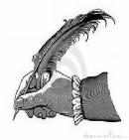 | “...I will tell you in what I know Americans parents to be most difficult-in hearing the faults of their children. In most instances, when you see the faults are not to be immediately corrected by the parents but rather by good advice and education, it is best not to speak of them to papa and mama, who feel as if you reflected on their very selves. While to you it will be, ‘Yes sir, I know...’ in the heart they think it is not so much and will soften and excuse the child [of] what they condemn to us, and our efforts afterwards avail very little.”

ACTIVITY
Does this remind you of your parents? Do you think parents of the 1800’s were much like the parents
of today? Would you think this way if you were a parent?
LETTER 6 from Sister Rose White’s journal: teaching schedule and regulations for the school week at St. Joseph’s 1812

“[Morning]-first class of grammar, Monday and Thursday, begins at 8:30 to 9:30; second class every day- Tuesday and Friday from 8:30-9:30, half of them sent alternately to writing; second class of spelling from 9:30-10:30 during which the third class will alternately go to figures and writing; third class of spelling from 10:30-11:30 during which the second will go alternately to figures and writing; from 11:30-12:30 the second and third classes will read alternately English... and French... Any of either class not learning French will read to [Sister Jane]... if necessary. Afternoon-second class of geography, during which French read alternately to Sr. Elizabeth; third class of geography, [Sister Jane]...; second class of reading, Sr. Margaret... Monday and Thursday; third class of reading [Sr. Jane]... Monday and Thursday, first class parsing; Thursday and Friday, second and third class[es] parsing, while second class parse, third class read French or repeat.”
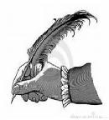
“...third class of grammar everyday, heard while first class writes; Monday and Thursday second class of grammar, half sent alternately to writing; first class of reading from 10:15 to 11:15; first class or spelling from 11:15 to 12:15; first class of geography (repetition) on Tuesday and Friday, four may read French alternately during the repetition; class of bookkeeping on Monday and Thursday succeeds the hour of writing, three quarters of an hour... first class of reading (six), each one five minutes, each to correct the other while the first class are writing; heathen mythology and French vocabulary 12:30. Afternoon- Monday, Tuesday, and Friday, a given quantity of French translation; Tuesday and Friday, practical geography; Monday and Thursday, Sister Fanny’s second class of reading assist [Sister] Cecilia with work.”
“The mode of teaching [is] not uniform. Can a child leave fine sewing occasionally? ... Ought the angel [ Sister in charge of the children] to be in the class room? Confusion on change of class... Children leaving school for drink, etc. Abuse going to clothes room... Silence in dormitory. Fruit withheld as punishment... Children sent out during class. Postures to be mended.”
12

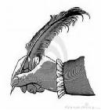 | LETTER 7 Elizabeth Ann Seton to Mr. Basil S. Elder 1813  January 18- “Among our fifty odd children we have very few as good as Eleanor... When you write her, you will speak to her of the necessity of silence in her class, diligence at her needle, and condescension to her playmates; these three points she is most deficient in, though really not materially faulty... If you really wish her to learn music... she must... sacrifice a part of the time allotted to needlework as... she could not be spared at any other time without too great a sacrifice of reading, grammar, spelling, or arithmetic so essential at her age. Additional charge for music is $8 a quarter.”

ACTIVITIES
- How many subjects that the children studied can you pick out in the letter? Do you have these same subjects today? Compare and contrast the curriculum of Mother Seton’s time with that of today.
- How is your life the same or different from a student attending St. Elizabeth Ann Seton’s school?
- Create an advertisement to be used to persuade someone to send their daughters to Mother Seton’s school.
13

Section 4: Daily Life

Read the following letters by Sister Rose White, one of the earliest members of Mother Seton’s community, to find out what daily life was like in the early 1800s.

LETTER 8 from Sister Rose White’s journal 1809
May 10- “[Father Dubourg’s] last words were to cultivate plenty of carrots...for coffee, which we used. That and rye were our morning and evening beverage for breakfast and supper... We walked every Sunday to the mountain [Mt. St. Mary’s College]... Then there was no bridge or road to the mountain. We had to go over one by one on horseback when the water was high, and when [it was] low, we walked over the creek on stones, climbed the fences, and often lost our way through the thick woods. We carried our dinner in a sack and often fried our meat at the mountain, took it from the frying pan, and placed it on a piece of bread without a knife or fork, ate standing, took a good drink of water, and went up to church... Often we were caught in the rain coming home, and at this time we never wore a shawl, much less [carried] an umbrella. When we came to the creek, we would meet a horse... sent to take us across. The oldest Sister remained standing in the rain by the oak tree until all had passed over; then, in her turn, she was taken and sometimes continued her ride to the farm house door....Our shoes were heavy with mud and our clothes so that we had to change them.”
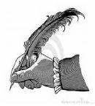
“ While sleeping at the Stone House, the snow would drift in. One morning Sister Sally and Sister Rose shovelled out nearly two cart-loads of snow in a garret where two of the Sisters were sleeping and did not discover that their beds were partly covered also...until day began to dawn through the cracks of the boards, the only fastenings for the windows...”
LETTER 9 from Sister Rose White’s journal 1809
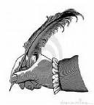
July 30- “Our washing place was at the creek where we took our clothes early in the morning and remained the day. [There was] not a plank to stand on or [any] covering but the tree under which we would place our tubs. If rain came on, we would have to bring [in] our clothes, all wet and heavy. [We had] no accommodations, no water to wash with at the house.”
LETTER 10 from Sister Rose White’s journal 1810
January 9- “We became so crowded that it was...necessary that some of us should come up to the new house [known as the White House] to sleep... [We] would often rise at two, three or four 0’clock and go down to the farm [house] thinking it was time for morning prayers. The ground was rough plowed and often very muddy. Sometimes we were forced to stay all day up at the new house [because] the rain was so heavy. One would go down and bring up something to eat. We had spinning wheels and kept ourselves employed.”
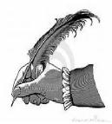
LETTER 11 Elizabeth Ann Seton’s letter to Julia Scott 1810
January 24- “Mr. Cooper [benefactor]... brought me for Cecelia a barrel of honey, one of treacle [molasses] which we make great use of, a box of Smyrna figs, one of raisins, one of prunes, and seventy or eighty yards of flannel besides pieces upon pieces of India chemise muslin...”

14

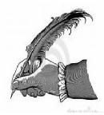 | LETTER 12 from Sister Rose White’s journal 1810  May 14- “Our school increased in numbers, both borders and day scholars. We had great difficulty in accommodating the boarders. The Sisters slept in the garret on the floor in the same place where the hair was for plastering. [The work on the new house was not complete yet]. Often we passed the night carrying our mattresses from one place to another to find rest, and we were so bitten by the fleas that our skins wore a purple appearance. We begin to take sewing from the Mountain to pay a debt that we owed. We made mattresses, quilted quilts and made all the boys’ clothes and mended. We did all our washing yet at the creek.”

ACTIVITIES
- If Mother Seton could visit us in the 21st century, how would you prepare her for all the changes? Do you think the changes are good? Why?
- Write a daily journal for a friend, as Mother Seton did, to tell of your day.
- What did Mother Seton and her Sisters eat for meals?
- Where would they get their meat, flour, sugar, and other supplies? How would they keep the food fresh?
15

Section 5: Saints and Shrines
Elizabeth Ann Seton is important in history because she was the first American-born saint. A saint is someone who has been recognized as having lived a very holy life (see the definition on the vocabulary page). In the Roman Catholic religion, a person is recognized as venerable, blessed (beatified), and saint (canonized).
One of the requirements for sainthood is that several miracles are recognized as occurring through the intercession of a holy person. The miracles that were officially attributed to Elizabeth Ann Seton by the church were:
- Gertrude Korzendorfer, a Sister of Charity, whose cancer of the pancreas disappeared in 1935;
- Ann Theresa O’Neill, a young child, who recovered from acute, lymphatic leukemia; and
- Carl Kalin, who recovered from a rare form of encephalitis after being close to death.
In 1974, Pope Pius VI waived the traditional requirement for a fourth miracle, and on September 14, 1975, Elizabeth Ann Bayley Seton was officially declared a saint.
ACTIVITIES
- Each of us is called to be a saint. Do you know what a saint is? List the qualities you think a saint should have.
- Make an “I am a saint” poster. On the poster list or draw the qualities you share with Saint Elizabeth Ann Seton.
- Make a saint booklet or collage: “A saint is someone who ____.”
Collage: print the sentence on paper and illustrate, cut out pictures from magazines, or bring in
family pictures that illustrate the way a saint acts. Example: picture of sharing, praying.
Booklet: Write a sentence describing a quality of a saint and illustrating it. When everyone is
finished, put the papers altogether into a booklet.
- A saint is someone who listens to God and does what God wants even when it is difficult. What qualities do you think made Elizabeth a saint? What difficulties did she go through in her life? Could you be a saint?
See the definition of a shrine on the vocabulary page. Occasionally the word is used to describe a memorial. People sometimes make a shrine in their homes or other places to honor their loved ones.
In 1991, the church in Emmitsburg in which St. Elizabeth Ann Seton is entombed was given the title of “minor basilica.” The term basilica is a special designation given by the pope to certain churches because of their antiquity, dignity, historical importance, or significance as a center of worship and devotion. The honor given to the Shrine of St. Elizabeth Ann Seton is a recognition of the importance of her contribution to the development of the Catholic Church in the United States. Today there are more than fifty minor basilicas in the United States. There are only four major basilicas in the world, all located in Rome, Italy.
16

ACTIVITIES

- In the White House, there is a chapel that Mother Seton and her community used to pray and
celebrate Mass. Look up the definitions of a chapel and a basilica. What are some differences between the White House chapel and the Seton Shrine’s Basilica? What are some things that could be found in both?
- Name up to three shrines that you have visited and compare them to the Shrine of Saint Elizabeth Ann Seton.
- In 1991, Pope John Paul II declares that the church is a minor basilica. What do you know about Pope John Paul II? List at least three facts about him.
- One of the stained-glass windows in the Seton Shrine’s Basilica shows the Daughters of Charity performing works of mercy. Research what these works of mercy are. How many are there? Talk about what types of good deeds you might do.

17

Section 6: The American Flag in Elizabeth Seton’s time
FLAG DATES
July 4, 1776
The Declaration of Independence was approved.
July 14, 1777
Congress passed a law making the stars and stripes America’s official flag: “...resolved, that the flag of the United States be Thirteen stripes alternate red and white, that the union be thirteen stars white on a blue field representing a new constellation.”
May 1, 1795
The 15-star, 15-stripe flag was authorized. This was the only flag to have more than 13 stripes. This flag
was used until July 4, 1818.
Sept. 13, 1814
Francis Scott Key wrote “The Star Spangled Banner” after the British attack on Fort McHenry in Baltimore, Maryland. Francis Scott Key is buried in nearby Mount Olivet Cemetery in Frederick, Maryland.
April 13, 1818
The Flag Act of 1818 was passed. It specified 13 stripes and a star for each state.
ACTIVITIES
- What did the flag look like when Mother Seton was living?
- Why are flags important to countries?
- How many flags did Mother Seton live under?
- What is a symbol? Explain the symbolism of the United States flag.
- Explain the symbolism of the flags of two other countries.
- List three places where the United States flag flies today.
- How do we show respect for the flag?
- Design a flag to represent you and your own identity. Include symbols of something important in your life or from your family’s traditions.
- With your classmates, make a joint flag to represent your class, incorporating symbols into a design.

18

Draw the Stars on the First American Flag

Post-Visit Activities
What can you do to reflect on your visit?
- Complete any of the following activities: Shrine Quiz, My Trip to Emmitsburg, Elizabeth’s Life-Timeline, or any of the word searches or puzzles.
- Create a vocabulary quiz from some of the terms used here.
- From what you have seen at the shrine, what are your conclusions about the Mother Seton and her community’s way of life?
- Write or talk about the Stone House, where the community first lived. Was it warm and comfortable? What furniture or rooms are missing from the Stone House and the White House that you would expect to have today? What did you see in those houses that you would use today?
- Select one item from the Stone House and research how this item was used in Early America.
- Compare and contrast what the early community ate and what you eat; what they wore and what you wear.
- Bring to class four items from home that you use today. Discuss what future historians might say about these artifacts. What do they reveal about American life in the 21st century?
- If children in the year 2250 were to visit student’s homes as they are today, how could they tell what the people ate, what they wore and how the families earned money?
- Write in a journal about your trip as St. Elizabeth Ann Seton did. What was your favorite part of the trip? Draw a picture of one of the sites you saw at the shrine.
- List three things that you would enjoy about living in Early America. List three things that you would not like and why.
- Design a timeline. Put the key events of American history above the line and the key events in Mother Seton’s life below the line.
- Select a virtue you believe Elizabeth Seton strongly portrayed. List the qualities or characteristics of this virtue. Use color to design an abstract picture that represents the virtue.
- Design a collage symbolizing Elizabeth Seton’s various roles during her life.
- Create a diorama of the school room in the White House.
20

Elizabeth’s Life- Timeline
Cut along the dotted lines. Place the paragraphs in order according to the events that happened in Mother Seton’s life. Draw a picture to go with each.
Some women came to help Elizabeth Ann Seton teach. They became the first sisters. They called her Mother Seton. Mother Seton taught them to love God and teach children.
Elizabeth Ann Seton died on January 4, 1821. There are many women who continue the work Mother Seton began.
Betty worked hard in school. She learned to read, write and sew. She also learned to play the piano. She played for her friends. They danced and marched.
When Betty Bayley grew up, she married William Magee Seton. Now her name was Elizabeth Ann Seton. William and Elizabeth loved each other very much. They had five children.
August 28 was a happy day for the Bayley family. It was the day Elizabeth Ann was born. Elizabeth’s mom, dad, and her sister, Mary, called her Betty.
All of the sisters worked together to keep the house and school clean. They cooked their food and washed their clothes. The sisters also taught the children.
21

ANSWER KEY-

Elizabeth’s Life - Timeline
August 28 was a happy day for the Bayley family. It was the day Elizabeth Ann was born. Elizabeth’s mom, dad, and her sister, Mary, called her Betty.
Betty worked hard in school. She learned to read, write and sew. She also learned to play the piano. She played for her friends. They danced and marched.
When Betty Bayley grew up, she married William Seton. Now her name was Elizabeth Ann Seton. William and Elizabeth loved each other very much. They had five children.
Some women came to help Elizabeth Ann Seton teach. They became the first sisters. They called her Mother Seton. Mother Seton taught them to love God and teach children.
All of the sisters worked together to keep the house and school clean. They cooked their food and washed their clothes. The sisters also taught the children.
Elizabeth Ann Seton died on January 4, 1821. There are many women who continue the work Mother Seton began.

22

QUIZ: Mother Seton and the National Shrine of St. Elizabeth Ann Seton
NAME

- In what city and state is the National Shrine of St. Elizabeth Ann Seton located?

Early Life
- In what year was Elizabeth Ann Seton (EAS) born?
A. 1750 B. 1774 C. 1796 D. 1812
- In what city was EAS born in?
A. New York B. Philadelphia C. Baltimore D. Boston
- What was EAS’s maiden name (Note: Extra point for correct spelling)?
- By what “nickname” did EAS parents’ call her?
- What was EAS religious faith as a child?
A. Catholic B. Baptist C. Episcopalian D. Presbyterian
- How old was EAS when she married?
A. 15 B. 19 C. 34 D. 47
- What was the first name of EAS husband?
- Of what disease did EAS husband die from?
A. Heart Attack B. Cancer C. Hepatitis D. Tuberculosis
- How many children did EAS and her husband have? What were their names? (Note: Extra point for each correct spelling)

- In an attempt to restore her husband’s health, to what country did EAS sail to?
- For approximately how many years was EAS married before her husband died?
A. 3 B. 17 C. 10 D. 23
Life after Death
- By what occupation did EAS try to support her family?
A. Maid B. Operate a School C. Operate a fish market D. Seamstress

23

14. What was the name of the first Catholic diocese in the United States?
15. What was the name of the Archbishop who convinced EAS to start a school in Baltimore?
A. John Carroll B. William Daly C. George Leech D. Carl Kalion
16. Approximately how old was EAS when she took her religious vows?
A. 19 B. 29 C. 35 D. 53
17. What was the name of the group that Elizabeth Ann Seton formed?
- Sisters of Charity of St. Joseph’s C. Sisters of Mercy
- Little Sisters of the Poor D. Daughter of Charity of St. Vincent de Paul
18. What was the name of the first house Mother Seton and her followers lived in?
A. Grey House B. White House C. St. Joseph’s House D. Stone House
19. Did Mother Seton teach poor boys of the area? TRUE FALSE
20. How many of Mother Seton’s children are buried in the cemetery near the mortuary chapel?
A. None B. One C. Two D. Three E. All
21. Where did Mother Seton die?
- In a hospital in Baltimore C. In the White House
- In the Stone House D. Near the chapel at the Grotto of Lourdes
22. Of what disease did Mother Seton die from?
A. Heart Attack B. Cancer C. Hepatitis D. Tuberculosis
23. How old was Mother Seton when she died?
A. 29 B. 35 C. 47 D. 88
24. Where were the remains of Mother Seton first interred?
- Under the main altar of the Basilica C. Under a side altar of the Basilica
- Under the chapel of the White House D. In the first cemetery of the Shrine’s campus
St. Elizabeth Ann Seton’s Legacy
25. How many miracles were officially attributed to EAS before she was declared “Blessed”?
26. Which Pope declared EAS a “Saint”?
A. Pius XII B. John XXIII C. Paul VI D. John Paul II
27. Which of the following is NOT true of St. EAS
- First American-born saint
- Founded the first Catholic School staffed by religious Sisters in the United States
- First saint to convert to Catholicism from another religious faith
- Shares her feast day with at least 8 other saints
28. When is St. EAS’s Feast Day?
A. January 4 B. July 4 C. October 4 D. December 4
29. Where are the remains of St. EAS interred today?
- Under the main altar of the Basilica C. Under a side altar of the Basilica
- Under the chapel of the White House D. In the first cemetery of the Shrine’s campus
30. The Stone House is located in the same spot as when St. EAS lived in it. TRUE FALSE
24

31. Which of the following can be found somewhere on the grounds of St. EAS Shrine?
- Gold urn containing the ashes of St. EAS’s husband?
- First statue of St. EAS erected in the United States
- Full-scale replica statues of each of St. EAS’s children?
- Gold-encrusted medallion of St. EAS donated to Pope Pius XII by St. EAS in remembrance of her canonization.
32. Which of the following are NOT depicted in the Basilica’s stained-glass windows?
- Corporal Works of Mercy C. Various Titles of Mary
- Seven Sorrow of Mary D. Stations of the Cross
33. In what item can a first-class relic of St. EAS be found in the front of the Altar of the Relics of St.
Elizabeth Ann Seton in the Basilica?
A. Cross B. Painting of EAS C. Miraculous Medal D. Mosaic of St. EAS
34. In what year did Pope John Paul II designate the St. Elizabeth Ann Seton Shrine Chapel as a
minor basilica?
A. 1907 B. 1944 C. 1991 D. 2001

25

QUIZ: Mother Seton and the National Shrine of St. Elizabeth Ann Seton
ANSWER KEY
1. In what city and state is the National Shrine of St. Elizabeth Ann Seton located?
Emmitsburg, Maryland
2. In what year was Elizabeth Ann Seton (EAS) born?
A. 1750 B. 1774 C. 1796 D. 1812
3. In what city was EAS born in?
A. New York B. Philadelphia C. Baltimore D. Boston
4. What was EAS’s maiden name (Note: Extra point for correct spelling)?
Bayley
5. By what “nickname” did EAS parents’ call her?
Betty
6. What was EAS religious faith as a child?
B. Catholic B. Baptist C. Episcopalian D. Presbyterian
7. How old was EAS when she married?
B. 15 B. 19 C. 34 D. 47
8. What was the first name of EAS husband?
William
9. Of what disease did EAS husband die from?
B. Heart Attack B. Cancer C. Hepatitis D. Tuberculosis
10. How many children did EAS and her husband have? What were their names? (Note: Extra point for each correct
spelling)
Five – Anna Marie (or Annina), William, Richard Bayley, Catherine, Rebecca
11. In an attempt to restore her husband’s health, to what country did EAS sail to?
Italy
12. For approximately how many years was EAS married before her husband died?
B. 3 B. 17 C. 10 D. 23
13. By what occupation did EAS try to support her family?
B. Maid B. Operate a School C. Operate a fish market D. Seamstress
14. What was the name of the first Catholic diocese in the United States?
Baltimore
15. What was the name of the Archbishop who convinced EAS to start a school in Baltimore?
A. John Carroll B. William Daly C. George Leech D. Carl Kalion
16. Approximately how old was EAS when she took her religious vows?
A. 19 B. 29 C. 35 D. 53
17. What was the name of the group that Mother Seton and four of her followers formed?
A.Sisters of Charity of St. Joseph’s C. Sisters of Mercy
B.Little Sisters of the Poor D. Daughter of Charity of St. Vincent de Paul
18. What was the name of the first house Mother Seton and her followers lived in?
A. Grey House B. White House C. St. Joseph’s House D. Stone House
26

19. Did Mother Seton teach poor boys of the area? TRUE FALSE
20. How many of Mother Seton’s children are buried in the cemetery near the mortuary chapel?
A. None B. One C. Two D. Three E. All
21. Where did Mother Seton die?
A.In a hospital in Baltimore C. In the White House
B.In the Stone House D. Near the chapel at the Grotto of Lourdes
22. Of what disease did Mother Seton die from?
A.Heart Attack B. Cancer C. Hepatitis D. Tuberculosis
23. How old was Mother Seton when she died?
A.29 B. 35 C. 47 D. 88
24. Where were the remains of Mother Seton first interred?
A.Under the main altar of the Basilica C. Under a side altar of the Basilica
B.Under the chapel of the White House D. In the first cemetery of the Shrine’s campus
25. How many miracles were officially attributed to EAS before she was declared “Blessed”? Two
26. Which Pope declared EAS a “Saint”?
A.Pius XII B. John XXIII C. Paul VI D. John Paul II
27. Which of the following is NOT true of St. EAS
A.First American-born saint
B.Founded the first Catholic School staffed by religious Sisters in the United States
- First saint to convert to Catholicism from another religious faith
- Shares her feast day with at least 8 other saints
28. When is St. EAS’s Feast Day?
A.January 4 B. July 4 C. October 4 D. December 4
29. Where are the remains of St. EAS interred today?
- Under the main altar of the Basilica C. Under a side altar of the Basilica
- Under the chapel of the White House D. In the first cemetery of the Shrine’s campus
30. The Stone House is located in the same spot as when St. EAS lived in it. TRUE FALSE
31. Which of the following can be found somewhere on the grounds of St. EAS Shrine?
A.Gold urn containing the ashes of St. EAS’s husband?
B.First statue of St. EAS erected in the United States
C.Full-scale replica statues of each of St. EAS’s children?
D.Gold-encrusted medallion of St. EAS donated to Pope Pius XII by St. EAS in remembrance of her
canonization
32. Which of the following are NOT depicted in the Basilica’s stained glass windows?
A.Corporal Works of Mercy C. Various Titles of Mary
B.Seven Sorrow of Mary D. Stations of the Cross
33. In what item can a first-class relic of St. EAS be found in the front of the Altar of the Relics of St. Elizabeth Ann Seton in the Basilica?
A. Cross B. Painting of EAS C. Miraculous Medal D. Mosaic of St. EAS
34. In what year did Pope John Paul II designate the St. Elizabeth Ann Seton Shrine Chapel as a minor basilica?
A.1907 B. 1944 C. 1991 D. 2001

27

MY TRIP TO EMMITSBURG, MARYLAND
RELIGION
In light of our visit to Emmitsburg, answer ONE of the following in a well thought out essay (four or five
paragraphs):
- What would it have been like to be a student at Mother Seton’s school?
- What are some differences between Mother Seton’s school and your school?
- Explain to a friend how the life of Elizabeth Seton could be a model for young people today.
- What was the most important thing that you learned from today’s trip?
MATH/SOCIAL STUDIES
- Using a map, estimate the distance between your school/home and Emmitsburg.
- Looking at your map, plan three different routes you could take to get from your school/home to Emmitsburg.
- Averaging 50 miles per hour, about how long will it take to get to Emmitsburg?
- What might affect the actual travel time to get there?
- Watch the amount of traffic as you travel. Why do you think some areas have more traffic than others?
- Describe the different geographic areas that you saw on the way to Emmitsburg or on the way home.
- From the information found on five different tombstones, determine the date of birth of those persons.
SCIENCE
- Name four different landforms that you saw today. Remember to watch from the bus.
- What was the weather like when we left school/home? What was it like when we arrived in Emmitsburg? What do you think was responsible for the difference?
- Describe the weather during the day: temperature, sky, precipitation. Note any differences or changes due to time of day and location.
SPELLING
- Make a list of 15 spelling words that are connected with today’s trip plus 2 bonus words.
- Use each in a sentence that show you know what the word means.
ART
- Describe, in 3 or 4 sentences, two different art forms that you saw while in Emmitsburg. Examples: stained-glass windows, mosaics, statues, sketches, paintings, and photographs.
- Describe any musical instruments that you saw.
- If you took pictures of your trip, create a photo journal.
Many thanks to Ms. Marilyn Borrell at St. Mary, Star of the Sea School in Indian Head, Maryland, for these excellent activities.
28

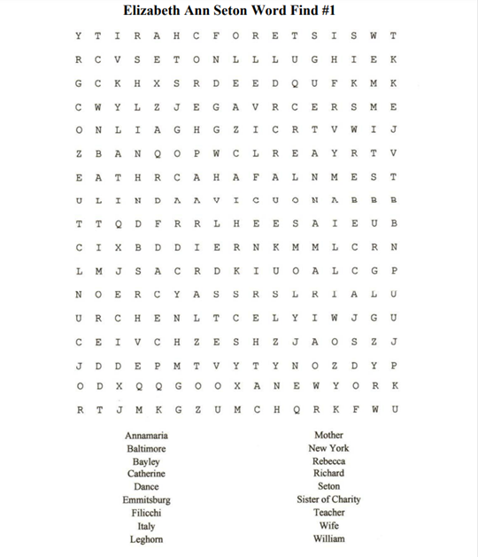

29

ANSWER KEY: ELIZABETH ANN SETON WORD FIND #1

30

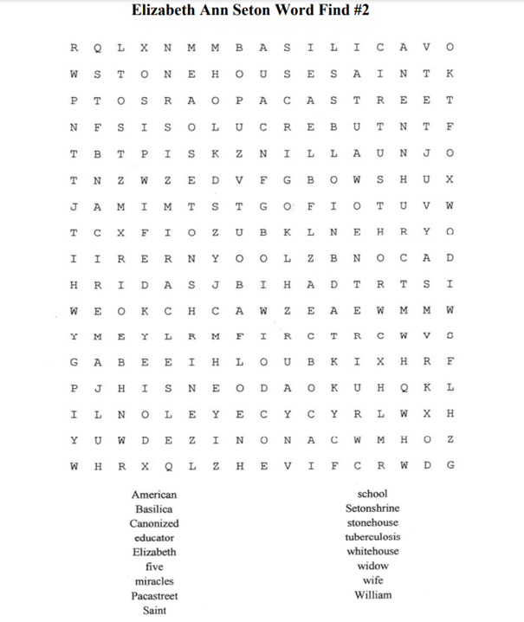
31

32

BASILICA PHOTO HUNT

The Basilica Photo Hunt is a fun activity. Students are given laminated cards with 20 color photos of parts of objects seen in the basilica and asked to find those. You provide the teacher/chaperones with answer keys by photocopying and distributing the next two pages ahead of time.
If you would like to participate in a basilica photo hunt, you must let us know in advance, and you will need to allow at least 30 minutes additional time in the basilica.
Below are samples of some of the pictures that are included in the hunt.
Please remember to print an answer key for every teacher/chaperone.

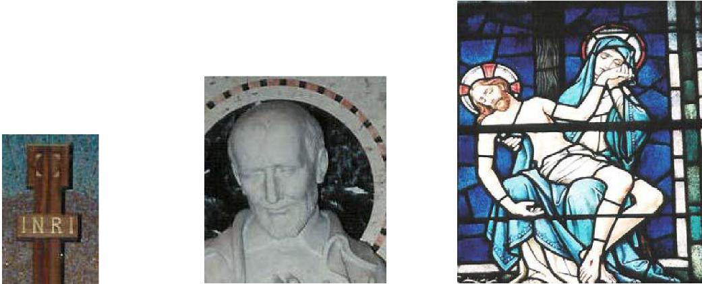

12 13 4

5 9 18
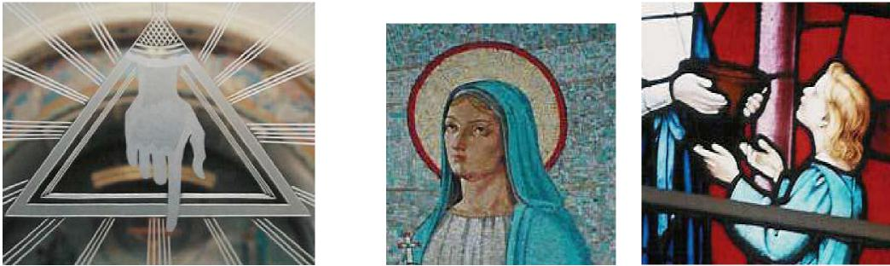
33

ANSWER KEY- BASILICA PHOTO HUNT
Teachers & chaperones, please help to maintain
quiet & calm during the photo hunt.
The chapel (now called the Basilica) was the heart of the new Provincial House which was first occupied by the Daughters of Charity on September 12, 1964. In 1991, Pope John Paul II designated the chapel a minor basilica. The marble, bronze, stained-glass windows, and mosaics are Italian or German, as were the artisan who constructed them.
INSTRUCTIONS FOR PHOTO HUNT (please allow an extra 30 minutes for this activity)
- Before your visit, print enough answer keys so that each teacher/chaperone has one.
- Divide your students into small groups, each headed by a teacher/chaperone.
- The docent will give you laminated Photo Hunt Cards to distribute to the students.
- Have the students go through the basilica, identifying each one of the photos.
- The teacher/chaperone can check off each one on the answer key as they are found, and tell the students about the history/explanation of each object.
- When the photo hunt is over, please return the laminated cards to the docent.
- Statue of Mary and the Altar of the Blessed Sacrament. The statue of Mary, Mother of God,
stands over the altar of the Blessed Sacrament. Here is the Real Presence of Jesus. Notice the
red vigil light and the bright light, telling us He is here. We kneel before the altar and adore Him.
The Eucharist was very important to Elizabeth Ann Seton. Listen to her words:
“Jesus, then, is there. We can receive him, He is our own... That he is there is as
certainly true as that bread naturally taken removes my hunger... so this bread of
angels removes my pain, my cares, warms, soothes, contents and renews my
whole being....”
- St. Catherine Labouré stained glass window. Catherine Labouré was born May 2, 1806 in the village of Fain-les-Moutiers in France, the 9th of 11 children. Catherine became a Daughter of Charity. In 1830, the Blessed Mother appeared to Catherine and asker her to have a medal made. This medal became known as the “Miraculous Medal.” She was canonized in 1947. She is wearing the habit that the Daughters of Charity wore until 1964. The large white headdress she wears is called a “cornette.”
- Mosaic of Angels. The mosaic representing the choirs of Angels forms a semi-circle over the Sanctuary; it is reminiscent of the Chapel of the Miraculous Medal at the Daughters of Charity Motherhouse in the Rue du Bac, Paris. Note that no two angels are in the same pose.
- Jesus is taken down from the Cross. Above the altar of Saint Louise de Marillac, there is a group of seven stained glass windows representing the Seven Sorrows of Mary. Here, Mary cradles her dead Son in her arms.
- Etched glass window of the Basilica door. The windows and the glass panels in the doors were produced in Germany by F. X. Zettler, Glasmalerei of Munich. The symbol shown here is in the panel of the center door. It is a triangle, which symbolizes the Blessed Trinity; the hand symbolizes the Hand of God the Father. Can you think of what the other images on the windows might symbolize (grapes, sheaves of wheat, doves, etc.)?

34

- The Holy Family. The only painting in the basilica, oil on canvas, on the ceiling of the dome. It depicts Joseph, a young Jesus, and mother Mary.
- Mary Window: Queen of Martyrs. The lower windows of the Basilica represent some of the many titles used for Mary, taken from the Litany of the Blessed Virgin Mary. The word “litany” comes from the Latin, litania. It is often recited as a question and response chant in a group setting.
- Statue of Saint Elizabeth Ann Seton. The altar of Saint Elizabeth Ann is also called “the Altar of the Relics.” The white marble statue of her is dressed in the habit which she and her Sisters of Charity wore in 1809. Under the altar, encased in marble, is the small copper casket containing her relics which were transferred here in 1968. For security reasons, a protective marble shield was installed in 1975.
- Mosaic of “Virgin Most Powerful.” In November 1830, Mary appeared to Catherine Labouré for the second time. The Queen of Heaven was seen with a globe under her feet and holding a smaller globe in her hands. Mary then revealed to Catherine the Miraculous Medal was to look like. Catherine was told, “... the persons who will wear it will receive great graces...these graces will be abundant for those who wear it with confidence.” The front and back of the Miraculous Medal are reproduced in bronze on the communion rail gates. The prayer on the medal is “O Mary conceived without sin, pray for us who have recourse to you.”
- Statue of St. Joseph. Saint Joseph is shown as a young man and a carpenter, as he was when he was chosen to be the spouse of Mary and the foster father of her Child. Elizabeth had a special affection for Saint Joseph, and called her community the Sisters of Charity of Saint Joseph’s. This Emmitsburg spot is often called “Saint Joseph’s Valley.”
- The 4th Station of the Cross: Jesus meets his sorrowful mother.
- Crucifix. INRI is an abbreviation of the Latin phrase “Iesvs Nazarenvs Rex Ivdaeorvm,” which translates as “Jesus of Nazareth, the King of the Jews.” Latin uses “I” instead of the English “J”, and “V” instead of “U” (Jesus Nazarenus Rex Judaeorum). Pilate had this inscription written in Hebrew, Latin, and Greek and put on the cross.
- Statue of St. Vincent DePaul. St. Vincent de Paul co-founded the Daughters of Charity in France
in November 1633. See the little symbol of the ship on the pedestal. St. Vincent referred to his
community as a “little bark,” or “boat:”
Have greater confidence in Him [God] than we do; let us allow him to steer our little bark; if it is
useful and pleasing to Him, He will save it from shipwreck.
#1478. Vincent de Paul to Achille Le Vazeux, 29 March 1652, Marie Poole, D.C.,
ed., Correspondence, Conferences, Documents, 14 vols. (New City Press,
1993), 4:347.
- Saint Louise de Marillac. Saint Louise de Marillac (1591-1660) co-founded Daughters of Charity in France in November 1633 to care for the sick poor in the villages and towns of France. She is the patron saint of Christian Social Workers.
- The mosaic of the Evangelist Saint Mark. The four Evangelists (Matthew, Mark, Luke, and John) are often represented by symbols. Mark’s symbol is a lion, usually winged, from “a lion roars in the desert” from the beginning of his gospel, referring to John the Baptist crying out in the desert. An Ox is the symbol for Saint Luke; a Cherub for Saint Matthew; and an Eagle for Saint John. Look for them on the four mosaics on the ceiling.

35

- Saint Patrick. The high windows of the basilica represent saints who have a special relevance for the Daughters of Charity mission and ministries. Saint Patrick is the patron saint of Ireland. What is he holding in his left hand? What does it symbolize?
- Saint Anne. Saint Anne and Saint Joachim (next to her) were the parents of Mary. St. Anne is often portrayed as teaching Mary. She is the patroness of housewives.
- The seven corporal works of mercy. The seven corporal works of mercy are represented in these windows. They are: feed the hungry; give drink to the thirsty; shelter the homeless; clothe the naked; visit the sick; visit the imprisoned; and bury the dead.
- Mary Window: Queen of the Holy Rosary. The rosary is an important and traditional devotions consisting of a set of prayer beads and a system set of prayers. What are the prayers? What is a decade?
- The coronation of Our Lady as Queen of Heaven and Earth. The coronation of Mary is one form of reverence frequently shown in images of Mary
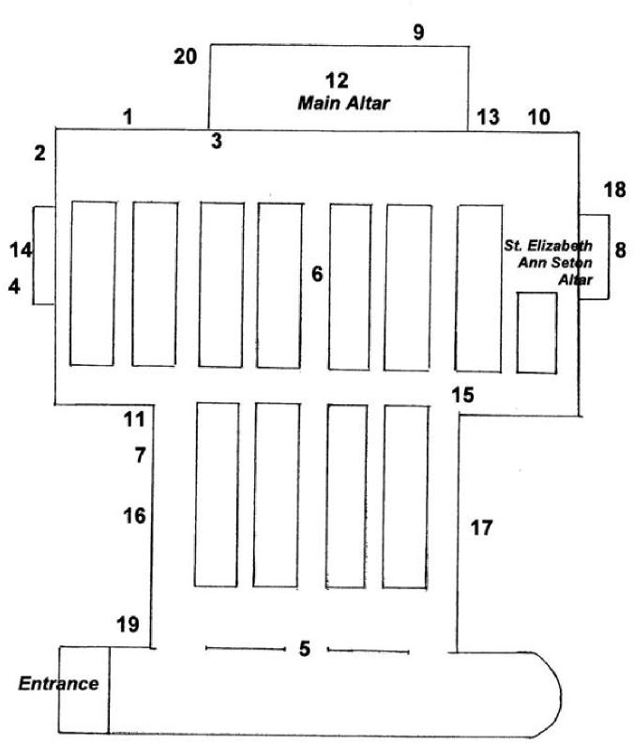

36

The Seton Search
The Seton Search is a fun activity for students to do while on tour or visiting museum. Saint Elizabeth Ann Seton was an extraordinary woman. She has left us a legacy filled with Love: Love of God and Love of Others. How many questions can you answer about her?
- In the museum, find 3 things that personally belonged to Mother Seton.
- Where did Elizabeth Ann Bayley grow up?
- What was her father’s profession?
- What were some of the joys in Elizabeth’s “five-year fairytale”?
- What charitable organization did Elizabeth help found in New York to aid widows and orphans?

- What hardships did she and her family encounter that caused them to travel to Italy?

- When did Elizabeth Ann Seton convert to the Catholic faith?
- When did Elizabeth receive her first communion?

- Where was Elizabeth’s first girl’s school located?
- What was the name of the order Elizabeth Ann Seton founded?

- When did She open St. Joseph’s School in Emmitsburg, MD?

- Where did Mother Seton send Sisters of Charity to open orphanages?

- Where are the remains of St. Elizabeth Ann Seton?
- When did she die?
- What was the cause of her death?
37
Vocabulary
apprentice- to work for another person for a specific amount of time in return for instruction in a trade.
basilica- a title of honor given to church buildings that are distinguished by their role as international centers of worship because of their association with a major saint or an important historical event.
beatified- the second of three stages of sainthood; declared as having attained the blessedness of heaven and authorized to bear the title “Blessed” and to have limited public religious honor.
berth- a built-in bed or bunk, as in a ship’s cabin or a Pullman car (train).
canonized- the third and final stage of sainthood, in which the person is officially recognized as a saint.
canonization- the event at which it is officially announced that a dead person is a saint.
cartage- moving items by cart.
chapel- a room within a larger building, which is used for Christian worship.
confine- to shut within an enclosure; to keep within bounds.
conveyed- to take or carry from one place to another.
cord- a unit of quantity for cut wood, equal to 128 cubic feet in a stack measuring 4 ft. high x 4 ft. deep x 8 ft. wide.
cultivate- to prepare for the raising of crops
docent- (from the Latin docere, “to teach) a person who is a knowledgeable guide, especially one who conducts visitors through a museum and delivers a commentary on the exhibitions.
engage - to obtain or contract for the services of another.
garret- the part of the house just under the roof.
grammar- the study of the classes of words
gross- total; entire.
holy- sacred; worthy of veneration; revered; living according to a strict or highly moral religious or spiritual system; saintly; specified or set apart for a religious purpose: a holy place; regarded as deserving special respect or reverence.
miracle- an event that appears inexplicable by the laws of nature and so is held to be an act of God.
38

parse- to give a grammatical description of a word
pensioner- a person who is dependent on the bounty of another.
pilgrimage- a journey, which is often long and difficult, to a special place for religious reasons. procure- to obtain; to acquire.
saint- the title given to a person who has received an official honor from a Christian, especially the Roman Catholic, Church for having lived in a good and holy way.
seminary- a school for the education of priests, ministers, sisters, or rabbis.
scholar- student, pupil, a learned man
shrine- 1) a place for worship which is holy because of a connection with a holy person or object. 2) a special place in which you remember and praise someone who has died, especially someone famous.
Sister- a female member of a religious group, especially a nun.
treacle- molasses, or a medicinal compound.
tuberculosis- a disease of human beings and some other vertebrates caused by a bacterium and usually marked by wasting, fever, and formation of cheesy tubercles that in human beings occur mostly in the lungs.
turnpike- a main road on which tolls are charged; a gate or bar set across a road to stop carriages, animals, and sometimes people, till toll is paid for keeping the road in repair; a tollgate.
venerable- the first of three stages of sainthood.
39

National Shrine of St. Elizabeth Ann Seton  339 South Seton Avenue  Emmitsburg, MD 21727 | 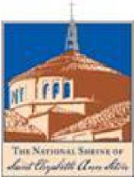

Thank you for visiting the Shrine of St. Elizabeth Ann Seton. When you have completed your visit and related activities, we ask that you please take just a few moments and fill out this evaluation so that we may improve our educator resources. We also encourage you to reproduce this form and solicit responses from your chaperones as well.
Teacher Evaluation
School/Group Name and Grade Level:
Date of Visit:
Your Name:
Email and Phone Number:
1. How did you hear about the National Shrine of St. Elizabeth Ann Seton?
- Was the Student Learning Packet of value to you as a teacher? YES NO
- How were your contacts with the following: Discovery Coordinator to reserve your tour:
Receptionist upon arrival:
Guides on the Seton Way Tour:
40

Docent in the Basilica:

- Please rate the following on a scale of 1 – 5 |  | (1 = poor, 5 = excellent):
Facilities | 1 | 2 | 3 | 4 | 5
Conditions of Exhibits | 1 | 2 | 3 | 4 | 5
Content of Tour | 1 | 2 | 3 | 4 | 5
Website (if used) | 1 | 2 | 3 | 4 | 5

- What did you like best about the visit to the Shrine?
- What aspects can you recommend improvement on?
Additional Comments
Thank you for your time!
Please return this evaluation to the address on the front.

41

